John Daton Steele
January 27, 1860 – April 22, 1949

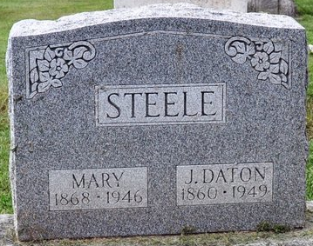
Photo by Deb Curry

John Daton Steele
in the Indiana, U.S., Death Certificates, 1899-2017
Name John Daton Steele
Gender Male
Race White
Marital Status Widowed
Age 89
Birth Date 27 Jan 1860
Birth Place Indiana
Death Date 22 Apr 1949
Death Place Rural, Adams, Indiana, USA
Death Registration Date 1949
Father Washington Steele
Mother Polly Zimmermann
Informant Edwin Booth; Decatur, Indiana
Burial April 22, 1949; Decatur Cemetery; Decatur, Indiana

