John Steele
July 21, 1838 – August 31, 1913

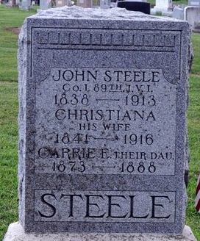
Photo by Deb Curry

John Steele
in the Indiana, U.S., Death Certificates, 1899-2017
Name John Steele
Gender Male
Race White
Marital Status Married
Age 75
Birth Date July 2?, 1838
Birth Place ?? Ohio
Death Date Aug 31, 1913
Death Place Decatur, Adams, Indiana, USA
Death Registration Date 1913
Father George Steele
Mother Margaret Shoup
Informant H. S. Steele
Burial Sept. ?, 1913; Decatur Cemetery

**
JOHN STEELE, farmer, also a carpenter, Washington Township, was born in Ashland County, Ohio, July 21, 1838, son of George and Margaret Steele, natives of Pennsylvania, the former of whom is deceased. In 1848 he came to Adams County with his parents, who settled in Kirkland Township, where his father entered 120 acres of land. Not a stick had been cut on the place. They endured many hardships, such as are common to the pioneers. The father was born in 1799 and died March 22, 1883. His wife survives him and is now in her eighty-third year. The parents had twelve children, nine of whom are living - Joseph, Washington, Henry, Samuel, Rebecca A., Caroline, Sarah A., Barbara A. and John. The father served several years as township treasurer and was universally respected.
Our subject was reared to manhood in this county and received a rudimentary education in the early pioneer schools. August 14, 1862, he enlisted in Company I, Eighty-ninth Indiana Infantry, and participated in the battle of Munfordville, the Meridian expedition, the Red River expedition, Fort Derusa, Pleasant Hill, Bayou la More, Yellow Bayou, Tupelo, and several others. His last fight was at Nashville and the siege of Fort Blakely. He was taken prisoner at Munfordville and paroled soon after and properly exchanged in due time. He was honorably discharged August 9, 1865, and returned to his home in Adams County.
He was married January 18, 1866, to Miss Christiana Smith, daughter of Jesse and Eliza Smith, early settlers of Kirkland Township. Mr. and Mrs. Steele have five children - Hervey S., Carrie M., Ella M., Laura A. and Annie C. Mr. Steele is a member of the Grand Army of the Republic, and in politics is a Democrat.

Biographical and Historical Record of Adams, & Wells Counties, Indiana

