Joe Victor Steele
July 5, 1898 – December 12, 1976

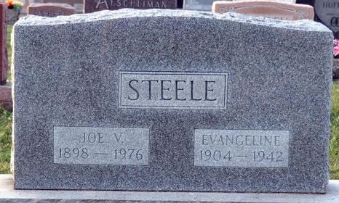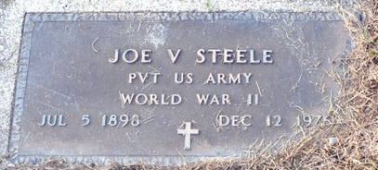
Photo by Deb Curry

Joe Victor Steele
in the Indiana, U.S., Death Certificates, 1899-2011
Name: Joe Victor Steele
Gender: Male
Race: White
Age: 78
Marital status: Never Married (Single)
Birth Date: 5 Jul 1898
Birth Place: Indiana
Death Date: 12 Dec 1976
Death Place: Decatur, Adams, Indiana, USA
Father: Jesse H. Steele
Mother: Niffie Cowan
Informant: Mrs. Gladys Koos; sister; Decatur, Indiana
Burial: December 15, 1976; Decatur Cemetery; Decatur, Indiana

