Jesse Hughes Steele
March 26, 1863 – April 28, 1946

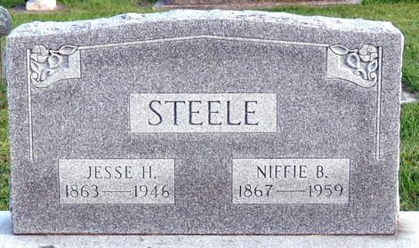
Photo by Deb Curry

Jesse Steele Dies at Pleasant Mills - Prominent Resident Dies Sunday Night

Jesse H. Steel, 83, prominent Pleasant Mills resident, former schoolteacher and a retired farmer, died at 10:10 o'clock Sunday night at his home. In failing health for some time, his condition had been critical for the past six days.
He was born in Adams County March 26, 1863, a son of Henry and Sarah Coffman-Steele, and was a lifelong resident of the county. He was married to Niffie Cowen in Waterloo on July 11, 1885, and Mrs. and Mrs. Steele celebrated the 60th wedding anniversary July 11 of last year. They spent their entire married life in Pleasant Mills.
Mr. Steele was a member of the first eighth grade graduating class in Adams County. He served as an attendance officer for two years and taught in various schools in the county for 29 years, retiring from the teaching profession in 1922. He was at one time principal of the Pleasant Mills High School and also served as St. Mary's Township assessor. He was a member of the Pleasant Mills Methodist Church.
Surviving in addition to the wife are three sons, Roy and Joe Steel, both of Pleasant Mills, and Guy Steel of Fort Wayne; eight daughters, Mrs. Edna Tumbleson of Fort Wayne, Mrs. Maud Holser of Walkerton, Mrs. Gladys Koos of Decatur, Mrs. Zula Holloway of Pleasant Mills, Mrs. Lelah Davis of Michigan City, Mrs. Pauline Hilty of Omaha, Neb., Mrs. Geraldine Miller of Decatur and Mrs. Mary Johnson of Middletown, O.; nine grandchildren and three great-grandchildren. Two daughters and three brothers preceded him in death.
Funeral services will be held at 2:30 o'clock Wednesday afternoon at the home in Pleasant Mills, with the Rev. Seth Painter officiating. Burial will be in Mr. Taber Cemetery. (sic) The body will be removed from the Zwick Funeral Home to the residence Tuesday morning at 10 o'clock.

Decatur Daily Democrat, Adams County, Indiana
Monday, April 29, 1946

**
Indiana, Death Certificates, 1899-2011

Name: Jesse H Steele
Gender: Male
Race: White
Age: 83
Marital Status: Married
Birth Date: 26 Mar 1863
Birth Place: Adams Co, Ind
Death Date: 28 Apr 1946
Death Place: Pleasant Mills, Adams, Indiana, USA
Father: Henry Steele
Mother: Sarah Coffman
Spouse: Sarah Coffman [sic: his mother)
Burial: May 1, 1946; Mt. Tabor Cem., near Decatur, Ind. [later moved to Decatur Cemetery]

