Ida Amelia Steele
September 4, 1884 – February 4, 1907

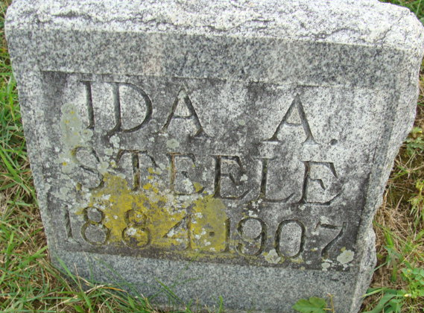
Photo by Alicia Kneuss

DEATH OF IDA A. STEELE
Miss Ida Amelia Steele died at the home of her mother, Mrs. Sarah Steele, 2120 Maumee Avenue of tuberculosis; deceased was 22 years of age.
Besides the mother, she is survived by three sisters and two brothers.
She was a member of First M. E. Church.
The remains will be shipped to Decatur for burial.

Fort Wayne News, Allen County, Indiana
February 4, 1907
**
Miss Ida Amelia Steele, daughter of Mrs. Amelia Steele, of 2120 Maumee Avenue, died Monday morning at 1 o'clock of tuberculosis at the age of twenty-two years.
She is survived by the mother, three brothers and two sisters.
Miss Steele was a member of the First Methodist Episcopal Church.
The interment will take place at Decatur.

Journal Gazette, Allen County, Indiana
February 5, 1907
**
The remains of Miss Ida Amelia Steele will be taken to Decatur today at noon for interment, brief funeral services being held from the residence, 2120 Maumee Avenue, prior to that hour.

Journal Gazette, Allen County, Indiana
February 6, 1907
**
Indiana, U.S., Death Certificates, 1899-2017
Name Ida Amelia Steele
Gender Female
Race White
Marital Status Single
Age 22
Birth Date 4 Sep 1884
Birth Place Peterson Ind Adams County
Death Date 4 Feb 1907
Death Place Fort Wayne, Allen, Indiana, USA
Death Registration Date 1907
Father Samuel S Steele
Mother Sarah J Krick
Informant Mrs. S. Jr. Steele; Fort Wayne, Indiana
Burial Feb. 6, 1907; Decatur, Indiana

