Helen L. (Lehrman) Steele
April 4, 1917 – May 5, 1991

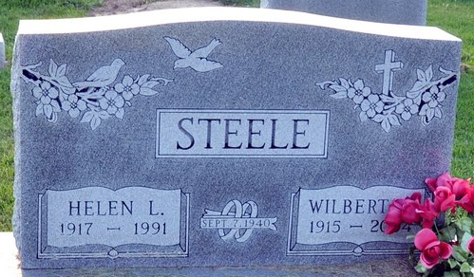
Photo by Deb Curry

Helen L Steele
in the Indiana, U.S., Death Certificates, 1899-2017
Name Helen L Steele
[Helen L Lehrman]
Gender Female
Race White
Marital Status Married
Age 74
Birth Date 4 Apr 1917
Birth Place Adams County, Indiana
Death Date 5 May 1991
Death Place Fort Wayne, Allen, Indiana, USA
Death Registration Date 1991
Father Ferdinand Lehrman
Mother Caroline Boknecht
Spouse Wilbert G Steele
Informant Wilbert G. Steele; husband; Decatur, Indiana
Burial May 8, 1991; Decatur Cemetery; Decatur, Indiana

