Hattie E. (Gibson) Steele
April 26, 1896 – January 20, 1987

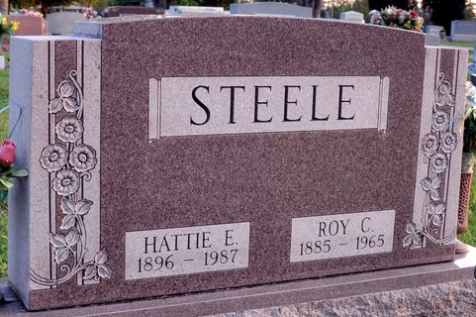
Photo by Deb Curry

Hattie E Steele
in the Indiana, U.S., Death Certificates, 1899-2017
Name Hattie E Steele
[Hattie E Gibson]
Gender Female
Race White
Marital Status Widowed
Age 90
Birth Date 26 Apr 1896
Birth Place Indiana
Death Date 20 Jan 1987
Death Place Decatur, Adams, Indiana, USA
Death Registration Date 1987
Father Alfred Gibson
Mother Jennie Hill
Informant Ellen Emenhiser; daughter; Decatur, Indiana
Burial January 23, 1987; Decatur Cemetery; Decatur, Indiana

