Harvey K. Steele
January 20, 1880 – February 25, 1880

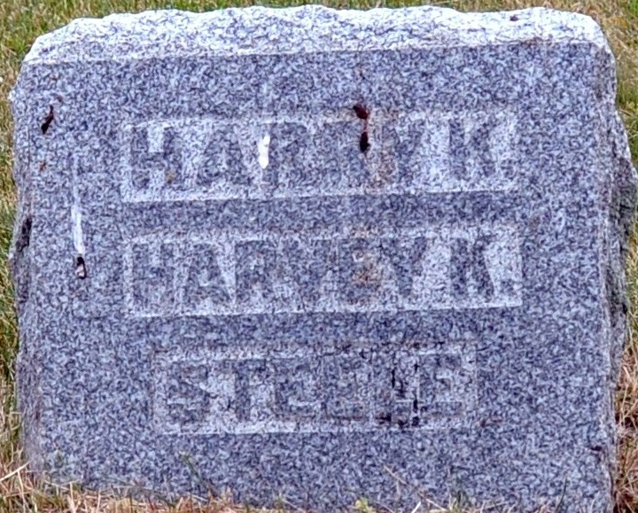
Photo by Deb Curry

Harvey E. Steele from tree EvansSteele
Birth 20 Jan 1880 Adams, Indiana, USA
Death 25 Feb 1880 Adams, Indiana, USA
Father Samuel Sands Steele (1856-1905)
Mother Sarah Jane Krick (1861-1944)

