Harry K. Steele
January 20, 1880 – February 5, 1880

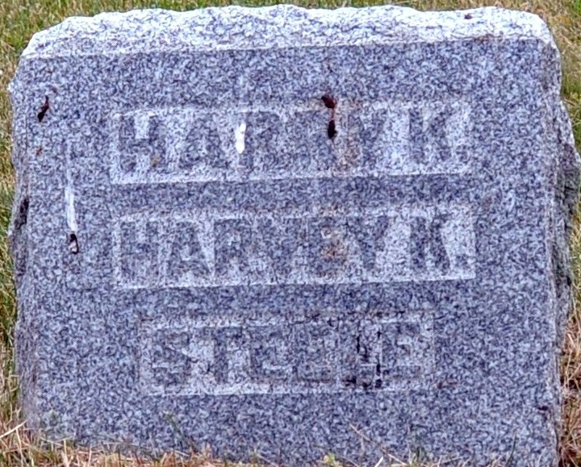
Photo by Deb Curry

Harry E. Steele from tree EvansSteele
Birth 20 Jan 1880 Adams, Indiana, USA
Death 5 Feb 1880 Adams, Indiana, USA
Father Samuel Sands Steele (1856-1905)
Mother Sarah Jane Krick (1861-1944)

