Grace J. (Poyner) Steele
September 23, 1898 – March 9, 1990

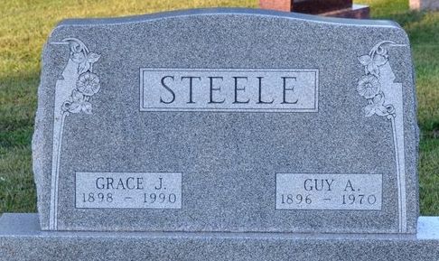
Photo by Deb Curry

Grace J. Steele, 91, Indian Rocks Beach, Florida, wife of a Decatur native, died Friday in Oak Manor Nursing Center, Largo, Florida. The native of Waynetown, Ill., married Guy Steele of Decatur, he died in 1970.
Surviving is a son, Edwin L. Steele, Indian Rocks Beach: 3 granddaughters, 5 great-grandchildren, and 1 great-great-grandson. Several relatives live in the Pleasant Mills area.
Funeral services are at 2 pm Wednesday at Zwick-Sefton and Jahn Funeral Home, Rev. William J. Cutshaw officiating. Burial will be in Decatur Cemetery. Visiting hours are at noon-2pm Wednesday.
Preferred memorials are to Calvary Episcopal Church, Indian Rocks Beach.
Unknown source

**
Florida Death Index, 1877-1998
Name: Grace Jane Steele
Death Date: 9 Mar 1990
County of Death: Pinellas; State of Death: Florida
Age at Death: 91; Race: White; Birth Date: 23 Sep 1898
**
U.S., Social Security Applications and Claims Index, 1936-2007
Name Grace J Steele [Grace J Poyner]
Gender Female
Race White
Birth Date 23 Sep 1898; Birth Place Vermillion, Illinois
Death Date 9 Mar 1990
Father Bert Poyner; Mother Almeda Surface
SSN xxx
Notes 02 Oct 1972: Name Listed As Grace J Steele

