George Ervin Steele
July 12, 1860 – July 17, 1918

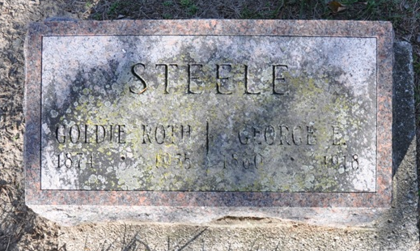
Photo by Deb Curry

BROTHER AND SISTER DEAD
Mrs. R. F. Mumma Died Early This Morning
Survives Her Brother GEORGE E. STEELE
By Less Than Twelve Hours - Mr. Steele Died Suddenly Last Night
Surviving her brother, George E. Steele, 58, well known plumber of First Street, Ellen, 69, wife of R. F. Mumma, of South Eleventh Street, died this morning at 6 o'clock. Mr. Steele passed away at about seven o'clock last evening.
Mr. Steele's death came very suddenly at the last. He had been troubled for years with heart trouble. For the past two weeks he had been ill of grip and neuralgia, and death was due at the last to angina pectoris, or neuralgia of the heart, following an attack of acute indigestion. Mr. Steele who had been confined to the house for a week or two had become better and was able to be up Monday and a part of yesterday. He had eaten a good supper last evening and a few minutes afterwards had become very ill of acute indigestion. The attack came on while he was in the bath room and aid was summoned hastily, the doctor and others arriving before he passed away, which, however, was only a few moments later.
The sister, Mrs. Mumma, had been ill for a number of years, being afflicted with outer goutre, which reacted upon the heart and stomach. She had been very ill since Sunday evening, and the shock of her brother's death probably hastened her own.
George Ervin Steele and Ellen Steele Mumma were born in Ashland, O., being son and daughter of Levi and Sarah Steele. They came to this county in 1861 when George, who was born July 12, 1860, was one year old, and Mrs. Mumma, who was born June 21, 1849, was twelve years old. Both of these deceased spent much of their life here, except for five years when George lived in Colorado and for the time that the Mumma's also lived in the west.
Mr. Steele was a pioneer plumber of this city, having been engaged in the plumbing and well-drilling business here for about twenty-two years. At the time of his death he conducted the business in the shop on First Street.
He is survived by the widow, who was Miss Goldie McKinney, of Russiaville, and a son, Ervin, aged twelve years. Mr. Steele observed his fifty-eighth birthday only last Saturday in a quiet way.
Mrs. Mumma is survived by the husband and nine children. The children are: Levi, George and Roy Mumma, of this city; Ida Harden, Bluffton; Emma Flynn, of Linton; Ella Ferguson, of Lyons, Indiana, Mrs. Philip Auth, Mrs. Al House and Mrs. Mary Cook in Colorado. Mrs. Mumma was a member of the United Brethren church.
The death of these two leaves the brothers, Dayton and Albert Steele of this city, the only surviving members of the Steele family. Brothers and sisters deceased are: John, who died at West Pullman, Chicago; Eva Gideon, of Paulding county, O.; Susanna Everett, of Colorado, and Mary Scott, of Monroeville.
There was some consideration of holding a double funeral but that has been found inadvisable. Arrangements for Mrs. Mumma's funeral will not be made until the daughters in Colorado are heard from.
The funeral of Mr. Steele will be held Friday afternoon at two o'clock June 19, from the Christian Church, preceded by a short service at the home. Burial of both will be in the Decatur Cemetery.
Decatur Daily Democrat, Adams County, Indiana
Wednesday, July 17, 1918

