George C. Steele
January 19, 1881 – April 19, 1925

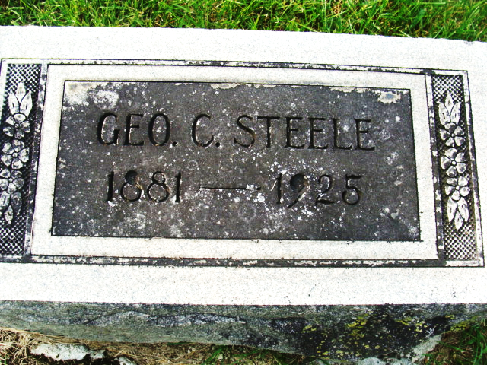
Photo by Alicia Kneuss

G. C. Steele Died Sunday, Former Merchant Succumbed to Brief Illness of Pneumonia
George C. Steele, age 44, former merchant in this city, died at his home on South Fifth Street at 12:30 Sunday afternoon following a brief illness of pneumonia. Mr. Steele was ill only five days.
Mr. Steele was the son of James A. and Victoria LeBrun Steele and was born in Richland township, Adams Co, IN, January 19, 1881. He spent his entire life in this community. For nineteen years he was engaged in the mercantile business, but about a year ago he sold his store in the north part of the city and since that time has been employed by Schuster Company. He was married to Irene Weaver on March 11, 1905. Mr. Steele was a member of the Yoeman Red Men and Pocahontas lodges. He held the offices of Forman of the Yoeman lodge and of Keeper of Records and Seals in the Red Men lodge at the time of his death. He was a member of the First Christian church also.
Mr. Steele is survived by his wife; two children Jeanette and Virginia, at home, his father and stepmother, five sisters, Mrs. Celia Canton of Lagrange, Mrs. Cora Pence of Sturgis, Michigan, Mrs. Rose Welker and Mrs. Bess Andrews of this city, and one brother, Earl Steele of Fort Wayne.
Funeral services will be held from the First Christian church at 2:30 o'clock Thursday afternoon, the Rev. R. W. Thomspon, pastor, officiating. Burial will be made in the Decatur Cemetery.
Decatur Daily Democrat, Adams County, Indiana
April 20, 1925

