Forest M. Steele
May 31, 1887 – December 15, 1939

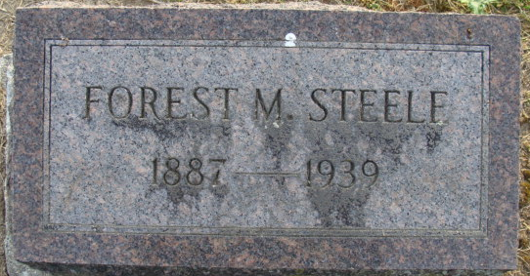
Photo by Alicia Kneuss

FORMER LOCAL RESIDENT DIES
Forest M. Steele Dies Friday Afternoon in Fort Wayne Hospital
Funeral services will be held Sunday afternoon in Fort Wayne for Forest M. (Dan) Steele, 52, a native of Decatur, now living in that city, who died Friday afternoon at the St. Joseph Hospital. Death was attributed to peritonitis. He was born in Decatur and was a veteran bricklayer.
Survivors include the mother, Mrs. Elizabeth Steele of Hammond; four sisters, Mrs. A. L. Hickman and Mrs. C. E. Barnhart of Hammond, Mrs. A. R. Parker of Fort Wayne and Mrs. C.V. Imler of Cedar Springs, Michigan; two brothers, Ernest E. Steele of Laketon and L. Eugene Steele of Hammond.
The body was taken to the Klaehn & Son Funeral Home in Fort Wayne where the services will be held Sunday afternoon at 2 o’clock.
The body will be brought to the Maplewood Cemetery in Decatur.

Decatur Daily Democrat, Adams County, Indiana
December 15, 1939
**
Indiana, U.S., Death Certificates, 1899-2017
Name Forest M. Steele
Gender Male
Race White
Marital Status Divorced
Age 52
Birth Date 31 May 1887
Birth Place Decatur, Indiana
Death Date 15 Dec 1939
Death Place Fort Wayne, Allen, Indiana, USA
Death Registration Date 1939
Father Dayton V. Steele
Mother Elizabeth R. Miller
Spouse Ruth
Informant Mrs. A. R. Parker
Burial December 17, 1939; Decatur, Indiana

