Evangeline H. Steele
November 17, 1904 – November 11, 1942

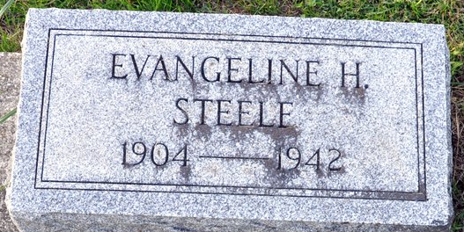
Photo by Deb Curry

Evangeline Steele is Taken by Death
School Teacher Dies at County Hospital
Miss Evangeline Steele, 37, for 8 years a teacher in Adams Co., Schools, died at 9:10 pm Wed., night at Adams Co. Memorial Hospital. Death was caused by meningitis after an illness of one month.
She was born in Adams County Nov. 17, 1904, the daughter of Jess H. and Niffie Cowen-Steele. She graduated from the Pleasant Mills High School in 1924 and from Manchester College in 1926. She was a member of the Pleasant Mills Methodist Church.
Surviving are the parents, Mr. and Mrs. Jess Steele of Pleasant Mills, with whom she made her home, and the following brothers and sisters; Mrs. Harvey Koos and Mrs. Richard Miller, both of Decatur; Mrs. D. H. Tumbleson and Guy Steele both of Fort Wayne; Roy and Joe Steele , both at home; Mrs. Bart Holser of Walkerton; Mrs. Murray Holloway of Pleasant Mills; Mrs. Richard Davis of Michigan City; Mrs. Fred B Hilty of Chicago and Mrs. Lawrence Johnson of Middletown, Ohio; one sister is deceased.
Funeral services will be held at 2 o'clock Saturday afternoon at the Steele residence, with Rev. Robert Johnson of the Pleasant Mills Methodist church officiating. Burial will be in the Mt. Tabor Cemetery(sic) near Bobo. The body will be removed from the Zwick Funeral Home at the Steele residence and may be viewed after 7 o'clock this evening. School children are requested to call at the home between 12 noon and 4 pm Friday.

Decatur Daily Democrat, Adams County, Indiana
November 12th, 1942

