Eli Willard Steele
March 11, 1857 – April 15, 1941

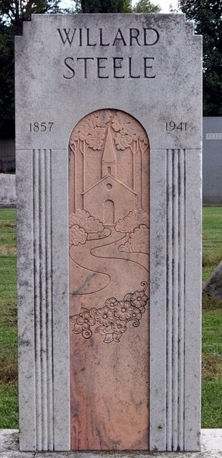
Photo by Deb Curry

Willard Steele Taken by Death
Wealthy Land Owner Dies This Morning at County Hospital
Eli Willard Steele, 84, wealthy land owner and widely known gardener of east of the city died this morning at 3:45 o'clock at the Adams County Memorial Hospital. Death was caused by complications and followed an illness of six months. He had been bedfast 10 days and was taken to the hospital last Friday.
Mr. Steele was one of the most widely known residents in Adams County. He was the builder of the former Steele's Park, later known as Belmont Park, and the scene of the once famous Northern Indiana Fairs, which featured harness horse racing. Mr. Steele, after securing the 75 acre track worked for the greater portion of two years planting and superintending the planting of thousands of maple trees and flower gardens in the park. It was nearly 50 years ago the he purchased and started beautifying the park, later building the race track and grandstands. After purchasing the park, Fred Reppert operated the fairs, which have since been abandoned.
It was during this time that he owned the park that he started the operation of his "vegetable wagon" delivery system, operation one wagon himself. Mr. Steele was a reputed wealthy man and the owner of considerable property.
He was born in Washington Township March, 11, 1857, the son of Washington and Polly Zimmerman Steele, His wife, Mary Steele, proceeded him in death.
Survivors are a sister, Mrs. Jacob Koos of Decatur and a brother, J. D Steele of Root Township. One sister is deceased.
Funeral services will be held Thursday afternoon at 2 o'clock at the Zwick Funeral Home, with Rev. George O. Walton officiating. Burial will be in the Decatur Cemetery. The body may be viewed after 2 p.m. Wednesday.
Decatur Daily Democrat, Adams County, Indiana
Tuesday, April 15, 1941

**
Plan Tombstone for One of County's Most Unusual Citizens
Decatur, May 29 – A tall white tombstone is soon to be erected in the Decatur Cemetery above the grave of one of Adams County’s most widely known citizens. The tombstone is to be unusual - unusual because it is to depict the life of Eli Willard Steele, known to most people as just Willard.
Willard Steele, before he died in April 1941, gained his renown because of his eccentricities, his hard-fisted rules of living economy and his zeal for hard labor and long hours, but above all his love for trees, shrubs and flowers.
These "hobbies" are to be portrayed on the stone, bearing little more than "Willard Steele, 1857-1941." Then, too, there is to be shown, hidden from all but a select few until after his death - his respect for the city's churches.
Willard Steele was not a man whom Decaturites would term a "churchgoer." There are those who had heard him say, "churches are all right - they are all right," but he "just didn't have the time for them."
In his will, however, he left each of the city's 12 churches of various faiths $2000. In addition he made a provision of $2000 for the Decatur Cemetery, $500 for the hospital and $500 for the library. The stately church hewed from the granite tombstone above his grave is to symbolize after his death what few knew when he was alive.
According to his brother, Dayton Steele, the man planned it all before he died. He told his brother the stone that he wanted and asked that it be erected over his grave, the brother stated.
Eugene Runyon, special administrator in the estate, was authorized by the court recently to erect the stone at a cost not to exceed $500 and workmen at the Wemhoff Monumental Works have been working arduously in an effort to erect the stone before Memorial Day.
With all due respect, it can be truthfully said that Willard Steele was one of the county's most unusual citizens. He lived frugally and economically - yet was reported to have often given freely. Many of the community's less fortunate are said to have capitalized on his latter virtue and to have lived in his or one of his houses, paying only a meager rent - or even none at all. Reputedly a man of considerable wealth, he often acted in the role of a "community band," lending money to this person and that.
There are many legends relative to his fondness for hard work and his contempt for leisure. The story is often told that when he once incurred an infection in his finger he inquired of the attending physician which would take longer - "cut it or cut it off?" He explained that he had too much work to be idle long.
His will? That is another story. Records in the Adams Circuit Court show that it has never been probated. Before it was probated an "objection to probate" was filed, alleging that he was "of unsound mind when he executed the will," that it was "unduly executed and "executed under duress." The "objection" was filed on the day of his funeral and the will filed a few hours later the same day.
Later a "complaint to resist probate" of the will was filed. The matter has never been settled. But the court has authorized the erection of the tombstone and that part of the will can be considered closed.
Willard Steele's was a story book life. He was the builder of "Steele's Park," east of Decatur; which was later to become Belmont Park after he sold it to Fred Reppert. It then became the scene of the famous northeastern Indiana fair.

Adams County (IN) Historical Museum
1941b Jan-Dec Scrapbook, image 009
Handwritten Date: Friday, May, 1942

**
Indiana, U.S., Death Certificates, 1899-2017
Name Eli Willard Steele
Gender Male
Race White
Marital Status Widowed
Age 84
Birth Date 11 Mar 1857
Birth Place Adams County, Indiana
Death Date 15 Apr 1941
Death Place Decatur, Adams, Indiana, USA
Death Registration Date 1941
Father Washington Steele
Mother Polly Zimmerman
Spouse Mary
Informant J. D. Steele; Decatur, Indiana
Burial April 15, 1941; Decatur Cemetery; Decatur, Indiana

