Edgar Steele
May 16, 1907 – May 5, 1992

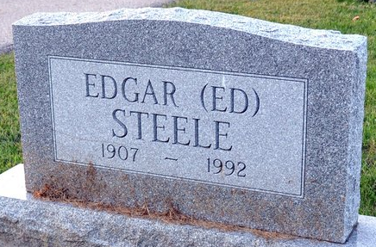
Photo by Deb Curry

Edgar Steele, 84, formerly of 122 N. Ninth St., died at 2:15 a.m. Tuesday in Lakeside Manor. He was born on May 16, 1907 in Decatur to Charles F. and Mary M. Plummer Steele. He was a retired employee of Eastern Express Lines, Fort Wayne, and a member of Jehovah's Witness Kingdom Hall, Decatur.
Surviving are two brothers, Ralph Steele, Fort Wayne, and Richard Steele, Jonesboro, Arkansas, and two sisters, Ida Mae Clem, Decatur, and Mrs. Fuhrman (Mary) Dellinger, Willshire, Ohio. Two brothers, Clyde and Chalmer Steele, are deceased.
Funeral services will be at 1:30 p.m. Thursday in Haggard and Armes Funeral Home, Rev. Roy Schwartz officiating. Burial will be in Decatur Cemetery. Visiting hours are 3-9 p.m. Wednesday.
Preferred memorials are to the donor's choice.

Decatur Daily Democrat, Adams County, Indiana
Wednesday, May 6, 1992

