Dora Alice Steele
January 24, 1866 – November 2, 1906

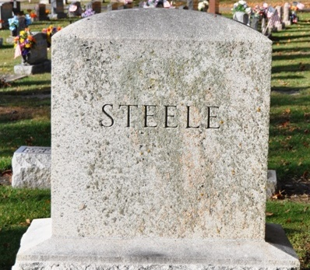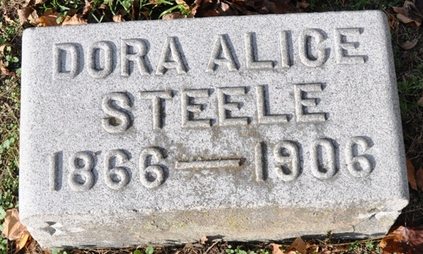
Photos by Deb Curry

WAS A POPULAR TEACHER
In the Primary Grades of the City
Schools Will Close During Hours of Funeral
Miss Dora Alice Steele, one of the most popular ladies of our city, died this morning at her home on North Fifth Street at two o'clock after an illness of a years' duration, death resulting from that dread disease, consumption.
She was born in Kirkland Township in the year 1866, where she was reared to womanhood, moving to this city when a young lady, together with her sister and engaging in the dressmaking business. Several years ago she took up the work as teacher in our public schools, at which she proved herself one of the foremost in her line. She taught in the schools until a year ago, when she was forced to resign her position owing to ill health, and from that time until her death her decline was gradual and this morning death relieved her from further suffering.
During the last two weeks of her illness she was so weak and infirm that she was utterly helpless and was forced to have a constant attendant. She was a member of the Methodist Church, was an earnest and devoted worker in its behalf, and her many acts of kindness and charity will be sadly missed by those who came in constant touch with her.
The funeral services will be held Monday morning at ten o'clock at the Methodist Church, Rev. John C. White officiating, and interment will be made in the Decatur Cemetery.
She leaves five sisters, namely, Mrs. Gault, of Monroeville, Mrs. C. C. Cloud, of this city, Mrs. Beery, Mrs. Straub and Miss Rebecca Steele to mourn their loss. Those desiring may view the remains any time Saturday or Sunday afternoon.
The schools will convene Monday morning but will adjourn after the first recitation to allow the teachers and the pupils to attend the funeral.

Decatur Democrat, Adams County, Indiana
A weekly newspaper
Thursday, November 8, 1906
**
The funeral of Miss Dora Steele was held this morning at the M. E. Church at 10 o'clock, Rev. John C. White officiating, and a large crowd being in attendance, to pay their last tribute of respect to the deceased.
The teachers of the Decatur Public Schools attended the funeral in a body, the schools having been dismissed for the morning. Interment was made in the Decatur Cemetery. The floral offering was beautiful and profuse.

Decatur Democrat, Adams County, Indiana
A weekly newspaper
Thursday, November 8, 1906

**
Indiana, Death Certificates, 1899-2011
Name: Dora Alice Steele
Gender: Female
Race: White
Age: 40 years, 9 months, 8 days
Marital status: Single
Birth Date: 24 Jan 1866; Birth Place: Kirkland Tp Adams Co Ind
Death Date: 2 Nov 1906; Death Place: Decatur, Adams, Indiana, USA
Father: Joseph Steele
Mother: Sarah Shady
Informant: Rebeca Steele; Decatur, Indiana
Burial: November 5, 1906; Maplewood Cemetery

