Dayton Vincent Steele
January 22, 1852 – January 7, 1933

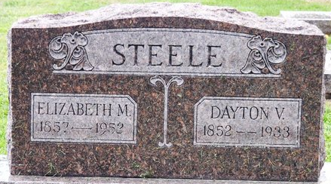
Photo by Deb Curry

Dayton Vincent Steele
in the Indiana, U.S., Death Certificates, 1899-2017
Name Dayton Vincent Steele
Gender Male
Race White
Marital Status Married
Age 80
Birth Date 22 Jan 1852
Birth Place Adams County, Indiana
Death Date 7 Jan 1933
Death Place Fort Wayne, Allen, Indiana, USA
Death Registration Date 1933
Father Levi Steele
Mother Sarah Galentine
Spouse Elizabeth
Informant Mrs. Elizabeth Steele
Burial January 9, 1933; Decatur, Indiana

