David Steele
November 6, 1840 – June 14, 1918

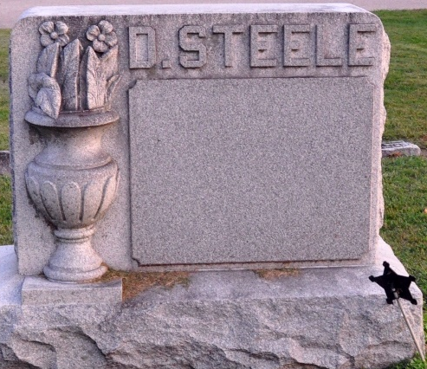
Photos by Deb Curry

DAVID STEELE, 77, DEAD AT DECATUR
Had Sisters Living In Bluffton - Buried At Decatur This Afternoon

David Steele, seventy-seven years of age, pioneer of Kirkland Township and Civil War veteran, died Friday evening at 8:30 o'clock at his residence, 814 North Third Street, where he had made his home with the L. F. Schoeder family for the past two months. Mr. Steele suffered the first hemorrhage of the bronchial tubes May 28, since when he had been bedfast. Last evening he suffered another and died during the hemorrhage, death coming very suddenly.
The deceased who was a son of the late Samuel and Susan Steele and was born in Kirkland Township, November 6, 1840, and had he lived until next November, would have been seventy-eight years of age. He was engaged in farming and resided in Kirkland Township until he retired from active life, when he came to this city. He had made his home with his children at times.
His wife, the late Mary E. Steele, is deceased.
Surviving children are Willard, of Alabama; Eva, of Rushville, O.; Charles F. Steele, Decatur; W. E. Steele, Pleasant Mills. There are six grandchildren. Brothers and sisters are Robert H. Steele, Decatur; George Steele, Tocsin; James A. Steele, Magley; Nancy Hower, Martha J. Watkins, Bluffton.
The body was removed to the home of a son, Charles F. Steele, on West Monroe Street, from which place the funeral will be held Monday afternoon at 3:30 o'clock, with the Rev. J. c. Hann in charge.
The funeral will be conducted by the local I.O.O.F., of which he was a member. - Decatur Democrat.

Evening Banner, Wells County, Indiana
June 17, 1918
**
Indiana, Death Certificates, 1899-2011
Name: David Steele
Gender: Male
Race: White
Age: 77
Marital Status: Widowed
Birth Date: 6 Nov 1840
Birth Place: Adams Co. Indiana
Death Date: 14 Jun 1918
Death Place: Decatur, Adams, Indiana, USA
Father: Samuel Steele
Spouse: Mary E. ?? Steele
Burial: June 17, 1918; Decatur Cem.

