Cinderella M. Steele
March 24, 1877 – February 17, 1893

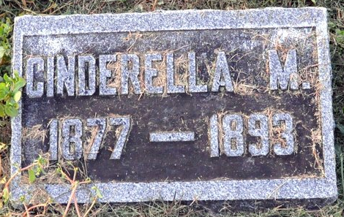
Photo by Deb Curry

Cinderella M Steele from tree Hibdon-Gideon Family Tree
Birth 24 Mar 1877 Adams, Indiana, USA
Residence 1880 Adams, Indiana, USA
Death 17 Feb 1893 Indiana, USA
Father David Steele (1840-1918)
Mother Mary Elizabeth Hixson (1844-1909)

