Christiana Serena (Smith) Steele
January 23, 1841 – December 1, 1916

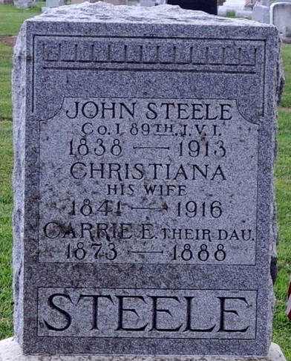
Photo by Deb Curry

HERE FOR BURIAL
Body of Mrs. Chrisanna Steele, Widow of John Steele, Brought Here.
Died in Fort Wayne - At Home of Daughter, Mrs. D. I. Weikel
Well Known Lady
Chrisanna Steele, widow of John Steele, long prominent and influential residents of Washington Township, this county, died yesterday afternoon at 3:30 o'clock at the home of her daughter, Mrs. D. I. Weikel in Fort Wayne, with whom she had been since August.
Mrs. Steele who as about seventy-five years of age, had resided with her children since the death of her husband three years ago last August. She had been ill for the past year, a complication of ailments undermining her health.
She was the daughter of Mr. and Mrs. Jesse Smith, and practically all her life was spent in the county and vicinity.
She is survived by four children - Ex-county Recorder Herbey Steele; Laura, wife of Albert Graber, this city; Ella, wife of D. I. Weikel, Fort Wayne; Annie, wife of Wilson Miller, Fort Wayne. Two sisters, Mrs. Nancy Parrish and Mrs. Ida Johnson, live in Monroe.
Mrs. Steele was an exemplary wife and mother, loving and kind, and thoughtful in her care of others.
The body was brought to her home on Ninth Street this city, where her son-in-law and daughter, Mrs. and Mrs. Albert Graber reside, and where they will lie in state until the funeral. The body was brought here at noon today in the Gay, Zwick & Myers ambulance and taken to the Albert Graber home on Ninth street until Monday afternoon, when the funeral will be held at 2 o'clock at either the United Brethren or M. E. church.
The deceased was seventy-five years, ten months and eight days of age.

Decatur Daily Democrat, Adams County, Indiana
Saturday, December 2, 1916
* *
Indiana, U.S., Death Certificates, 1899-2017
Name Christiana Serena Steele
[Christiana Serena Smith]
Gender Female
Race White
Marital Status Widowed
Age 75
Birth Date 23 Jan 1841
Birth Place Fairfield Co Ohio
Death Date 1 Dec 1916
Death Place Fort Wayne, Allen, Indiana, USA
Death Registration Date 1916
Father Jesse Smith
Mother Eliza Nutter
Spouse John B. Steele
Informant H. S. Steele; Decatur, Indiana
Burial December 4, 1916; Decatur Cemetery

