Carrie E. Steele
August 17, 1873 – December 26, 1888

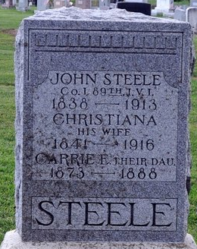
Photo by Deb Curry

Carrie M. Steele from tree Derr-Smolinski Family Tree
Birth 17 Aug 1873 Decatur, Adams, Indiana, USA
Residence 1880 Adams, Indiana, USA
Death 26 Dec 1888 Decatur, Adams, Indiana, USA
Father John Steele (1838-1913)
Mother Christiana Serena Smith (1841-1916)

