Cario Gertrude (Standiford) Steele
August 1, 1897 – May 2, 1930

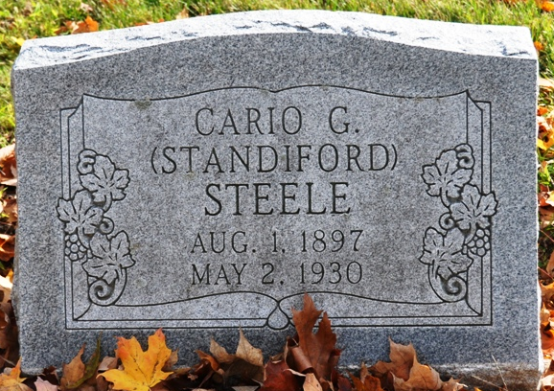
Photo by Deb Curry

FUNERAL SUNDAY
Funeral services for Mrs. Cario Gertrude Steele, 32 of 515 E. Second St., who died Friday afternoon at St. Rita's Hospital, will be at 12:30 p.m. Sunday at the residence of Clyde Standford (sic), 1027 Hughes Ave., with the Rev. E. W. Blumequist officiating, and at 3 p.m. at the First Baptist Church at Decatur, Ind. Burial will be in Decatur.
She was the wife of Herbert J. Steele.
In addition to the husband, she leaves 3 sons: Donald, Paul and Lowell and a daughter, Rosalind, all at home; four brothers, Clyde Standford (sic) of Lima, Merlin of North Homestead, O., Paris of Ft. Wayne and Harold of Sturgis, Mich; two sisters, Mrs. V. G. Shisserly (sic) of Sturgis, and Mrs. Ida Radenaker (sic) of Lima.

Lima News, Allen County, Ohio
Saturday, May 3, 1930

**
Collection: Ohio Deaths 1908-1953
Name: Cario Gertrude Stelle
Death date: 02 May 1930; Death place: Lima, Allen, Ohio
Birth date: 01 Aug 1897; Birth place: Van Werte Co., Ohio
Age at death: 32 years 9 months 1 day; Gender: Female
Marital status: Married; Race or color: Caucasian
Street address: 515 E. Second St.; Occupation: Housewife
Burial date: 04 May 1930; Burial place: Decatur, Ind.
Spouse name: Herbert Stelle
Father name: Chas. Standiford b. OH
Mother name: Jenevva Merrica b. OH
Informant Clyde V. Standiford of 1027 Hughes Ave.
GSU film number: 1992091; Digital GS number: 4000543; Image number: 838; Reference number: fn 27636

