Brenda Lou Steele
November 17, 1947 – November 17, 1947

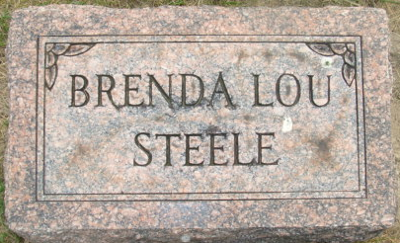
Photo by Alicia Kneuss

Brenda Lau Steele
in the Indiana, U.S., Death Certificates, 1899-2017
Name Brenda Lou Steele
Gender Female
Race White
Marital Status Single
Age 10 hours
Birth Date 17 Nov 1947
Birth Place Decatur, Indiana
Death Date 17 Nov 1947; premature
Death Place Decatur, Adams, Indiana, USA
Death Registration Date 1947
Father Wilbert S Steele
Mother Helen Lehrman
Informant Wilbert Steele; Decatur, Indiana
Burial November 17, 1947; Decatur Cemetery; Decatur, Indiana

