Bessie Bell Steele
June 23, 1884 – May 11, 1904

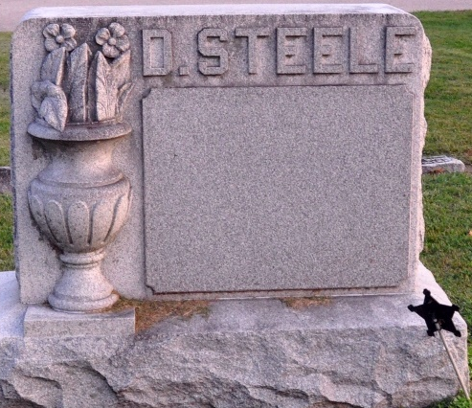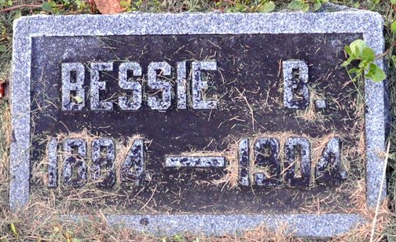
Photos by Deb Curry

Bessie Bell Steel
in the Indiana, Death Certificates, 1899-2011
Name: Bessie Bell Steel
Gender: Female
Race: White
Age: 19
Marital Status: Single
Birth Date: 23 Jun 1884
Birth Place: Ind Adams
Death Date: 11 May 1904
Death Place: Kirkland, Adams, Indiana, USA
Father: Dave Steel
Mother: Mary E Hixon
Informant: Mary E. Steel; Peterson, Ind.
Burial: May 13, 1904; Antioch Cem. (sic)

