Asher Steele
May 2, 1810 – July 28, 1825

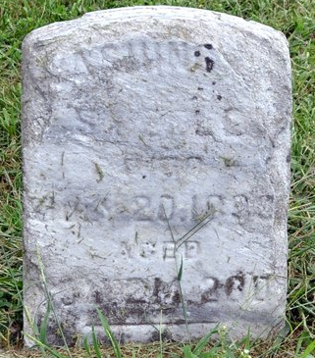
Photo by Deb Curry

No further information found at this time

