Wilma Irene (Chronister) Stauffer
October 8, 1911 – March 3, 1956

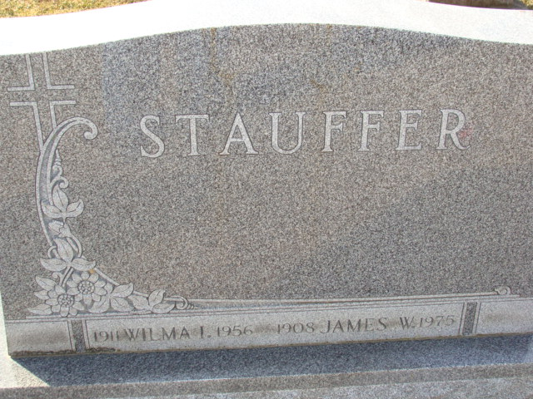
Photos by Alicia Kneuss

WIFE OF JAMES STAUFFER IS DEAD
Decatur Woman, 44, Dies After Brief Illness

Mrs. Wilma Irene Stauffer, 44, wife of James W. Stauffer, of Decatur, died at 6:10 p.m. Saturday in Parkview Memorial Hospital in Fort Wayne. She suffered a cerebral hemorrhage about six hours before her death.
Surviving is the husband, a daughter, Judy, at home, and the father, James Chronister, Decatur.
Mrs. Stauffer was a member of the Zion Evangelical and Reformed Church at Decatur.
Services will be conducted at 2 p.m. Wednesday at this church, following a short service at 1:30 p.m. in the Black Funeral Home in Decatur where friends may call after 7:00 p.m. today. Rev. William C. Feller will officiate and burial will be in the Decatur Cemetery.

The Berne Witness; Adams County, Indiana
Monday, March 5, 1956
**
Indiana, U.S., Birth Certificates, 1907-1944
Name Wilma Irene Chronister
Gender Female
Birth Date 8 Oct 1911
Birth Place Decatur, Adams, Indiana, USA
Father James T Chronister
Mother Nannie S Meese
Certificate Number 411
Roll number 40474_357952
Volume Range 363 - 367

