Thelma I. (Brown) Stauffer
April 28, 1907 – November 1, 2002

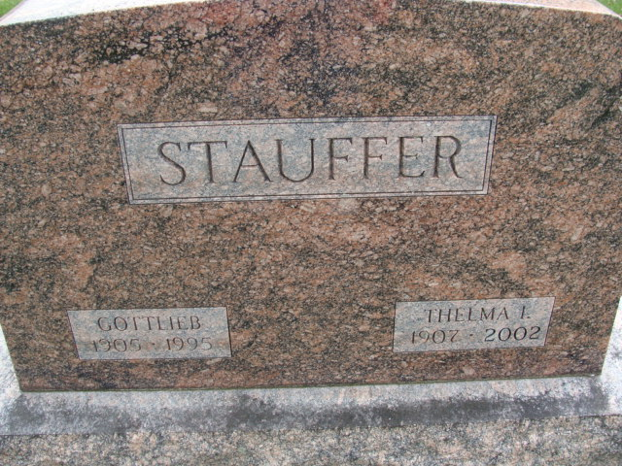
Photos by Alicia Kneuss

Thelma I. Stauffer, 95, a native of Wells County and a former resident of Decatur, died Friday November 1, at Hallmark Nursing Home in Summerville, N.C.
Surviving are a son, Jack S. of Summerville; a sister, Naomi Mora of Monterey, Calif.; four grandchildren; and seven great-grandchildren. Her husband, Gottlieb, and a daughter, Lenora V. Stauffer are deceased.
Services were held Monday at Haggard & Sefton Funeral Home in Decatur, Ind., and burial was in Decatur Cemetery.
Memorials to Zion United Church of Christ in Decatur.

Bluffton News-Banner, Wells County, Indiana
November 5, 2002

