Revia M. (Hammond) Stauffer -Olson
November 24, 1907 – January 3, 1997

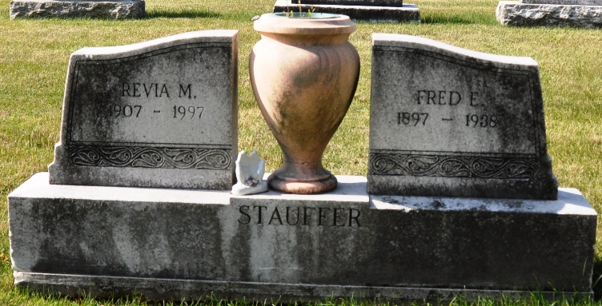
Photo by Deb Curry

Revia Olson, 89, of Decatur died Friday at Woodcrest Nursing Care, Decatur.
The Bluffton native is survived by her sister, Ruth Strickler.
Services are 11 a.m. Monday at Haggard and Armes Funeral Home, Decatur, with burial in Decatur Cemetery. Calling is from 2 to 4 and 6 to 8 p.m. Sunday at the funeral home.
Memorials to Pleasant Dale Church of the Brethren.

News-Sentinel, Allen County, Indiana
Saturday, January 4, 1997
**
Revia Olson
in the Indiana, U.S., Death Certificates, 1899-2017
Name Revia Olson
[Revia Hammond]
Gender Female
Race White
Marital Status Divorced
Age 89
Birth Date 24 Nov 1907
Birth Place Bluffton, Indiana
Death Date 3 Jan 1997
Death Place Decatur, Adams, Indiana, USA
Death Registration Date 1997
Father Fred E Hammond
Mother Lillie M Whitright
Informant Robert Hammond; brother; Decatur, Indiana
Burial January 6, 1997; Decatur Cemetery; Decatur, Indiana

**
Collection: Indiana, Marriages, 1811-1959
Groom: Charley Dean Byerly
Groom's Race: White; Groom's Date of Birth: 23 Dec 1892; Groom's Place of Birth: , Adams, Indiana; Groom's Residence: Decatur, , Indiana; Groom's Number of Marriage: 2
Groom's Father: D M Byerly; Groom's Mother: Dora Huston
Bride: Revia Stauffer
Bride's Race: White; Bride's Date of Birth: 24 Nov 1907; Bride's Place of Birth: Bluffton, , Indiana; Bride's Residence: Decatur, ,; Bride's Number of Marriage: 2
Bride's Father: Fred Hammond; Bride's Mother: Lily Whitright
Date of License: 19 Jan 1951; Date of Marriage: 20 Jan 1951; Place of Marriage:
Record Number: 595; GSU Film Number: 2322601; Digital GS Number: 4186035; Digital Image Number: 00584; Number of Images: 1

