Lucile (Rabbitt) Stauffer
March 10, 1894 – February 16, 1974

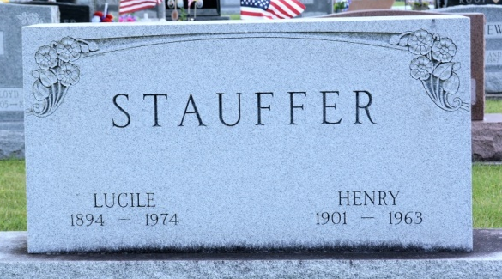
Photo by Deb Curry

Lucile Stauffer Dies this Morning
Mrs. Lucile Stauffer, 79, of 1611 Nuttman Ave., widow of Henry Stauffer, died at 4:05 a.m. this morning at the Adams County Memorial Hospital, where she had been hospitalized 10 days. She was a member of the Zion United Church of Christ.
Born in Adams County on March 10, 1894, she was the daughter of Charles and Mary A. Drummond-Rabbitt, and was married to Henry Stauffer on May 1, 1920, and he died on March 21, 1963.
Surviving are two sisters, Miss Erma Rabbitt of Decatur, and Mrs. Jerome (Dorothy) DeBolt of Tampa, Fla.; two brothers, Edwin Rabbitt of Largo, Fla. and Earl Rabbitt of Florida, and several nieces and nephews.
Funeral services will be held Monday at 1:30 p.m. at the Winteregg-Linn and Haggard Funeral Home, with Rev. Howard Beer officiating. Burial will be in the Decatur Cemetery. Friends may call at the funeral home after 2 p.m. Sunday.

Decatur Daily Democrat, Adams County, Indiana
Saturday, February 16, 1974

