James W. Stauffer
October 21, 1908 – September 10, 1975

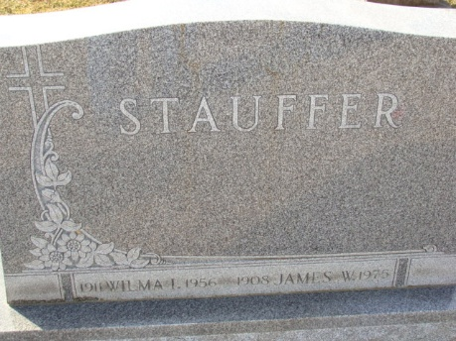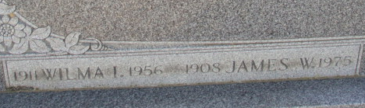
Photos by Alicia Kneuss

James W. Stauffer, 66, of Fort Wayne, died Wednesday in Lutheran Hospital, Fort Wayne. A retired foreman at General Electric Co., he had lived in Fort Wayne for 16 years. Mr. Stauffer was a former resident of Decatur.
Surviving are his widow, Gertrude; a daughter, Mrs. Thomas J. (Judith) Zeser of Decatur; a son, Jack, of Fort Wayne; three brothers, Gottlieb of Decatur; Noah of Chestnut, Ill., and Amos of Willshire; and five sisters, Mrs. Anthony (Louisa) Meyers and Mrs. Merlin (Rose) Ross, both of Decatur, and Mrs. Bertha VanCamp, Mrs. Clarence (Frieda) DeArmond and Mrs. Elnora DeArmond, all of Fort Wayne.
Funeral services will be at 10:30 a.m. EST Saturday in Winteregg-Linn & Haggard Funeral Home in Decatur. Burial will be in Decatur Cemetery. Friends may call at the funeral home where Masonic services will be held at 7 p.m. today.

Times Bulletin, Van Wert County, Ohio
Friday, September 12, 1975

**
Indiana, U.S., Death Certificates, 1899-2017
Name James W Stauffer
Gender Male
Race White
Marital Status Married
Age 66
Birth Date 21 Oct 1908
Birth Place Indiana
Death Date 10 Sep 1975
Death Place Fort Wayne, Allen, Indiana, USA
Father Frederick Stauffer
Mother Rebecca Duer
Spouse Gertrude Hughes
Informant Mrs. James Stauffer; wife; Fort Wayne, Indiana
Burial September 13, 1975; Decatur Cemetery; Decatur, Indiana

