Gottlieb Stauffer
May 11, 1905 – September 13, 1995

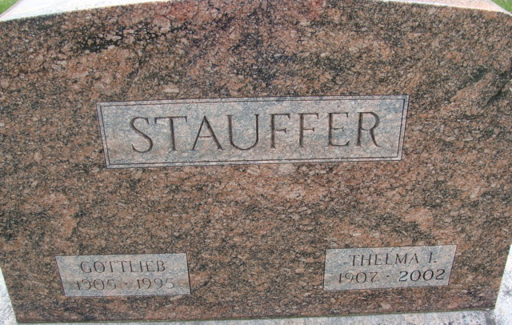
Photo by Alicia Kneuss

Gottlieb Stauffer, 90, of Summerville, S.C. - services have been scheduled for 1:30 p.m. tomorrow in Haggard & Armes Funeral Home, Decatur, with burial in Decatur Cemetery. Calling is 2 to 4 and 6 to 8 p.m. today in the funeral home, with a Masonic memorial service at 7:45 p.m.
Preferred memorials are gifts to Zion United Church of Christ in Decatur or the Decatur Masonic Lodge.

News-Sentinel, Allen County, Indiana
Saturday, September 16, 1995
**
U.S., Social Security Applications and Claims Index, 1936-2007
Name Gottlieb Stauffer
Gender Male
Birth Date 11 May 1905
Death Date 13 Sep 1995
Claim Date 16 Mar 1970
SSN xxx
**
Indiana, U.S., Marriage Certificates, 1960-2012
Name Gottlieb Stauffer
Marriage Date 1 Feb 1926
Marriage Place Whitley, Indiana, USA
Father Frederick Stauffer
Mother Lessie Dann [sic - Duer]
Spouse Thelma I Brown
Other Person Tony Meyers
Officiator R F Wilson

