Fred E. Stauffer
September 30, 1897 – February 22, 1938

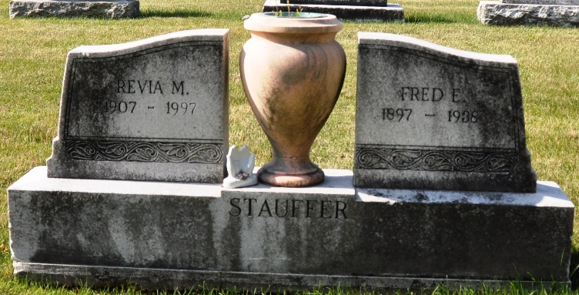
Photo by Deb Curry

Fred E Stauffer
in the Indiana, U.S., Death Certificates, 1899-2017
Name Fred E Stauffer
Gender Male
Race White
Marital Status Married
Age 40
Birth Date 30 Sep 1897
Birth Place Indiana
Death Date 22 Feb 1938
Death Place Fort Wayne, Allen, Indiana, USA
Death Registration Date 1938
Father Fred Stauffer
Mother Rebecca Duer
Spouse Revia Hammond
Informant Mrs. Revia Stauffer
Burial February 25, 1938; Decatur

