John Starfinger
April 26, 1888 – January 9, 1971

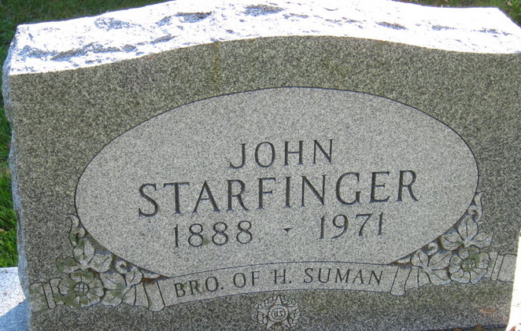
Photo by S Riley

JOHN STARFINGER DIES AT HOSPITAL

John Starfinger, 82, who had made his home for the past two and one-half years with a niece, Mrs. Ruth Hurst of Decatur route 6, died at 11:55 p.m. Saturday at the Adams County Memorial Hospital, where he had been a patient one week.
He was born in Cincinnati, O., April 26, 1888, a son of George and Kate Hartmann-Starfinger, and was never married. He was a veteran of World War I and resided in Milwaukee, Ore., for 63 years before moving to Adams County.
Surviving is a brother, Harry Suman of Decatur route 6; two nieces and ten nephews. A sister, Dora, is deceased.
Funeral rites will be held at 1:30 p.m. Tuesday at the Zwick Funeral Home, with Rev. Robert James officiating. Burial will be in the Decatur Cemetery. Friends may call at the funeral home until time of services.

Decatur Daily Democrat, Adams County, Indiana
January 11, 1971

