Tony Wayne Stapleton
July 25, 1949 – April 19, 1969

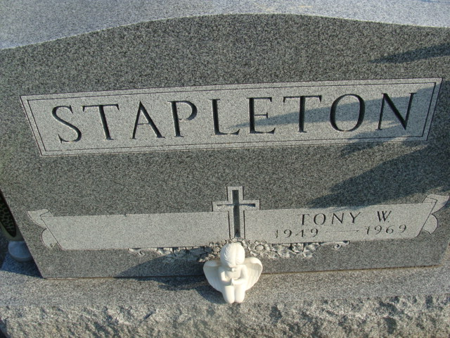
Photo by Alicia Kneuss

Tony W. Stapleton, 19, Dies of Wreck Injuries

Adams County recorded its first traffic fatality of the year this morning with the death of 19-year-old Tony Wayne Stapleton, 221 North Third Street. The Decatur youth died at 3:15 a.m. in the Parkview Memorial Hospital, Fort Wayne, from injuries received nearly a week ago in a one-car accident on U.S. Highway 33, just southeast of Decatur. Stapleton was the first person to die in a county auto crash since November 9, 1968.
Stapleton was injured when the car in which he was a passenger struck a horse at approximately 1:30 a.m. Sunday and then careened into an iron gate at the Robert Bookout residence, Decatur Route 6. He had been in critical condition since the accident.
David B. Steele, 20, Decatur Route 5, driver of the small American-made sports car, was also injured in the crash. However, he was released from the Adams County Memorial Hospital earlier this week. The horse, owned by William Melcher, Decatur Route 6, had gotten out of its enclosed area and was loose on the federal highway when the accident occurred. The horse was killed by the impact.
Lifelong Resident
Tony Wayne Stapleton was born in Decatur July 25, 1948 (sic), to Clarence A. and Eleanor L. Smith-Stapleton. The father is a partner in Culligan Sales & Service, Inc., in this city. The traffic victim graduated from the Decatur High School in 1967 and was employed as a barber at Gene's Barber Shop on the St. Joe Road in Fort Wayne. The Stapleton youth was a member of the Decatur Church of God.
Surviving are his parents; one sister, Miss Nancy Ann Stapleton, a sophomore at Bellmont High School; and the maternal grandmother, Mrs. Audrey A. Smith of Harlan.
Funeral services will be conducted at 1:30 p.m. Tuesday at the Church of God, with Rev. James E. Johnson officiating. Burial will be in the Decatur Cemetery. Friends may call at the Zwick Funeral Home after 2 p.m. Sunday. The body will lie in state at the church from 12 noon Tuesday until time of the services.

Decatur Daily Democrat, Adams County, Indiana
Saturday, April 19, 1969

