Eleanor L. (Smith) Stapleton
February 23, 1927 – September 18, 2023

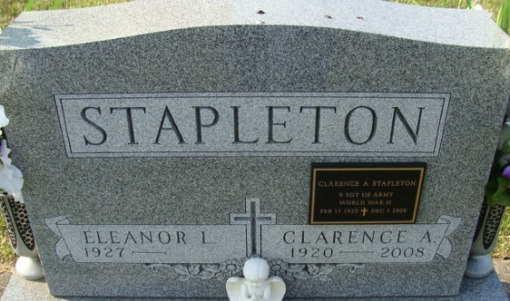
Photo by Alicia Kneuss

Eleanor L. Stapleton, 96, of Decatur, Indiana passed away Monday, September 18, 2023, at her residence. She was born on February 23, 1927, in Fort Wayne, Indiana to the late George and Audrey (Applegate) Smith. Eleanor was united in marriage to Clarence Stapleton on November 15, 1947, in Woodburn, Indiana and he preceded her in death on December 1, 2008.
She was a long-time member of Decatur Church of God, Indiana and was a member in the choir for over 50 years. Eleanor spent many hours at the church being involved in Sunday School as a teacher, the kitchen committee, junior church superintendent and helped in the nursery.
She worked at GE in Production for two years, following GE she served as activities director at Lakeside Manor and also worked in the office. She also served in the sales for the Kiddie Shop and Merle Norman in cosmetics.
Eleanor enjoyed crocheting and spending time singing in the choir, taking various trips with friends and family. She also took great pride in her appearance, especially her beautiful red hair. However, what brought her the most joy was spending time with her family and her fur baby Tony.
She is survived by a daughter, Nancy (Ed) Steiner of Decatur, Indiana; granddaughter, Christine (James) Cantwell of Bloomington, Indiana; great-granddaughter, Raegan Clare; two nephews, Rex and Don Moore.
In addition to her parents and husband, she was also preceded in death by a son, Tony Wayne Stapleton on April 19, 1969; two sisters, Betty Woods and Violet Moore; three brothers, Donald, Carl and Paul Smith and great-grandson, Evan Cantwell.
A funeral service will be held at 11:00 a.m. on Saturday, September 23, 2023, at Decatur Church of God with Pastor Matt Moore and Life Celebrant Molly Farthing officiating. Burial will follow at Decatur Cemetery. Friends and family will be received from 5 p.m. -8 p.m. on Friday, September 22, 2023, at Zwick & Jahn Funeral Home in Decatur and one hour prior to services at the church on Saturday.
Preferred memorials are to Decatur Church of God - building fund.

Zwick & Jahn Funeral Home, Adams County, Indiana
September 18, 2023

