Clarence A. Stapleton
February 17, 1920 – December 1, 2008

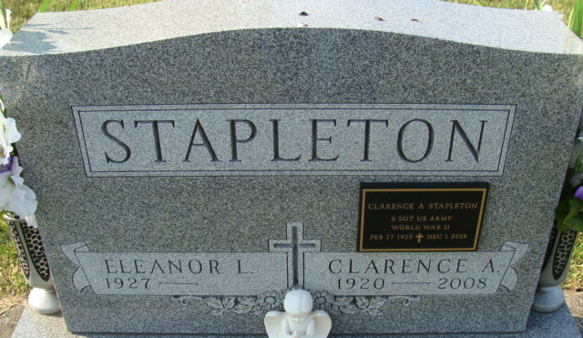
Photo by Alicia Kneuss

Clarence A. Stapleton, 88, of Decatur, Monday, Dec. 1, 2008, 12:38 p.m., at Adams Memorial Hospital following an extended illness. He married Eleanor L. Smith on Nov. 15, 1947, in Woodburn; she survives in Decatur.
He retired in 2004 from P & H Supply as a salesman; had worked for Meyer Plumbing and Hauk's Plumbing; and was a member of Decatur Church of God.
Also surviving are his daughter, Nancy A. (Ed) Steiner of Decatur; and granddaughter, Christine (James) Cantwell of Bloomington. He was preceded in death by one son, Tony Wayne Stapleton on April 19, 1969.
Service is 10:30 a.m. Friday at Decatur Church of God, with visitation one hour prior. Visitation also from 2 to 5 and 6 to 8 p.m. Thursday at Zwick & Jahn Funeral Home, Decatur.
Preferred memorials to the Decatur Church of God Choir.

Fort Wayne Newspapers, Allen County, Indiana
December 3, 2008

**
Indiana, U.S., Death Certificates, 1899-2017
Name Clarence A Stapleton
Gender Male
Race White
Marital Status Married
Age 88
Birth Date 17 Feb 1920; Birth Place Fort Wayne, Indiana
Death Date 1 Dec 2008; Death Place Decatur, Adams, Indiana, USA
Death Registration Date 2008
Father Clarence Stapleton
Mother Eva Grasshoff
Spouse Eleanor L Smith
Informant Eleanor L. Stapleton; wife; Decatur, Indiana
Burial Decatur Cemetery; Decatur, Indiana

