Wilbur R. Stanley
June 20, 1894 – November 23, 1983

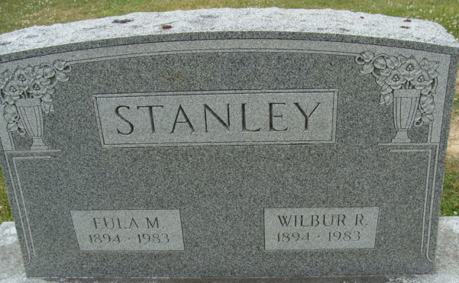
Photo by Alicia Kneuss

Wilbur R. Stanley
in the Indiana, U.S., Death Certificates, 1899-2017
Name Wilbur R. Stanley
Gender Male
Race White
Marital Status Widowed
Age 89
Birth Date 20 Jun 1894
Birth Place Indiana
Death Date 23 Nov 1983
Death Place Decatur, Adams, Indiana, USA
Death Registration Date 1983
Father George Stanley
Mother Johanna Thornton
Informant Floyd E. Marshand; guardian; Decatur, Indiana
Burial November 26, 1983; Decatur Cemetery; Decatur, Indiana

