Ralph Fremont Stanley
September 23, 1887 – July 6, 1962

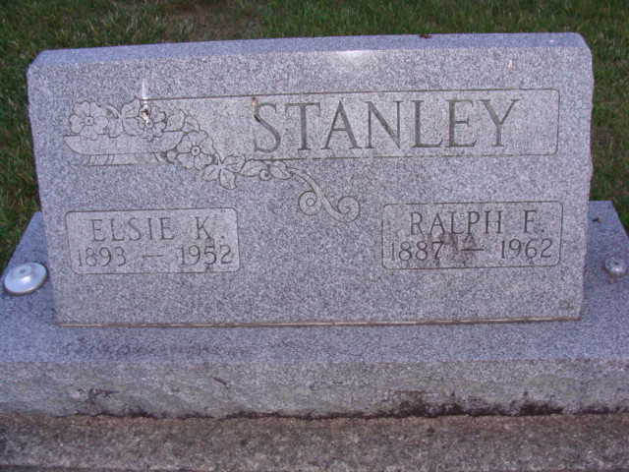
Photos by Alicia Kneuss

Handwritten date: Saturday, July 7, 1962
Ralph F. Stanley Dies Unexpectedly
Ralph Fremont Stanley, 74, former resident of Decatur, died at 5:30 p.m. Friday at the hospital at Hartford City, 20 minutes after admittance following a heart attack.
He was a native of Hartford City but resided in Decatur until six years ago, when he returned to Hartford City. He was a retired tool and die maker from the Decatur plant of the General Electric Co.
Mr. Stanley was a member of the Fort Wayne Masonic Lodge (32nd Degree), and a member of the G.E. Quarter Century Club. His first wife, Elsie Schaefer, died in 1952, and he later married Bessie Fuller Cook.
Surviving in addition to his wife are one son, Russell T. Stanley of Decatur; one daughter, Mrs. Rose Marie Hey of Churubusco; one stepdaughter, Mrs. Harold Wischern of Fort Wayne; four grandchildren; one step-grandchild, and a sister, Mrs. Sam Simison of Hartford City.
Funeral services will be conducted at 10 a.m. Monday at the Keplinger Funeral Home in Hartford City, the Rev. Russell Hiatt officiating. Burial will be in the Decatur Cemetery. Friends may call at the funeral home after 1:30 p.m. today.
Adams County Historical Museum, Adams County, Indiana
January 1951 – August 1962 Scrapbook, image 73

**
Indiana, U.S., Death Certificates, 1899-2011
Name: Ralph F Stanley
Gender: Male
Race: White
Age: 74
Marital status: Married
Birth Date: 23 Sep 1887
Birth Place: Indiana
Death Date: 6 Jul 1962
Death Place: Hartford, Blackford, Indiana, USA
Father: Levi Stanley
Mother: Mary Lanning
Informant: Mrs. Bessie Stanley; wife; Hartford City, Indiana
Burial: July 9, 1962; Decatur Cemetery; Decatur, Indiana

