Patty A. “Pat” (Dick) Stanley
June 17, 1930 – February 14, 2015

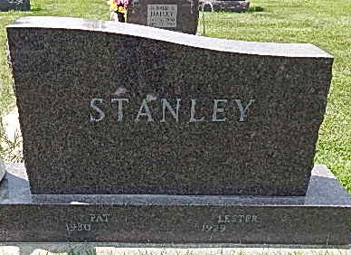
Photo by Alicia Kneuss

Patty A. Stanley, 84 years old of Decatur, Indiana, passed away at 5:44 p.m. on Saturday, February 14, 2015 in the Adams Woodcrest. Patty was born on Tuesday, June 17, 1930 in Bluffton, Indiana the daughter of the late Carl Dick and the late Lucy (Aker) Dick.
Patty was attending the Bridge Community Church in Decatur; a member of the Women of the Moose; the American Legion Post Auxiliary.
Patty was employed by Bowmar Aerospace for 20 years, retiring in 1989. She had also worked at CTS in Berne for 10 years after her retirement from Bowmar. Following retirement from CTS she worked at Woodcrest as a CNA for 10 years.
Surviving are her daughter, Brenda (George) Thomas of Bluffton, IN; daughter, Camala Sue (Rick) Horther of Decatur, IN; daughter, Kimm Yvette (Steve) Adams of Decatur, IN; son, Jeffery Helblig of Decatur, IN; sister, Jane DeRoo of Decatur, IN; 17 grandchildren, 5 step-grandchildren, 21 great-grandchildren, 11 step-great-grandchildren. Preceding Patty in death were 2 sons, Merle Wayne Fox & Robert Eugene Fox; 2 sisters, Peggy McBride & Florence Dick; 2 brothers, Clarence Dick & Merle Dick; 1 grandchild, Sue Ann Adams; 1 great-grandchild, John Michael Villanueva.
Funeral services will be held at 10:30 a.m. Thursday, February 19, 2015 in the Zwick & Jahn Funeral Home with Missy Fox officiating. Interment will follow in the Decatur Cemetery.

Zwick & Jahn Funeral Home, Adams County, Indiana
February 15, 2015

