Lester Lee Stanley
March 8, 1929 – July 14, 2010

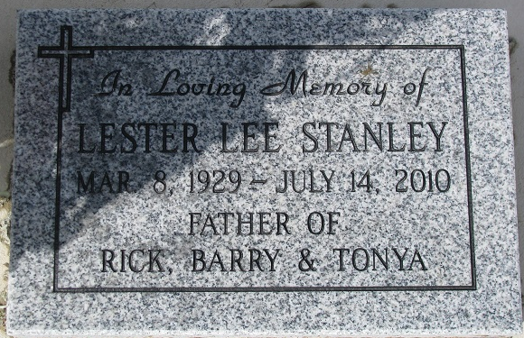
Photo by PLS

Lester Lee Stanley, 81, of McKinney, Texas, and formerly of Bluffton, passed away on Wednesday, July 14, 2010. He was born on March 8, 1929, in Geneva, to Cora and Delmar Stanley.
Survivors include his wife, Pat; two sons, Rick (Barbara) Stanley of Moreno Valley, Calif., and Barry Stanley of New Corydon; a daughter, Tonya (Dave) Smith of Geneva; four grandsons, Travis (Jamie) Smith of Geneva, Landon (Rachel) Smith of Berne, Ryan Smith of Geneva, and Eric Stanley of New Haven; six great granddaughters, Madison, Alison, Emmerson, Hailey and Adalyn Smith and Ciara Stanley; and two sisters, Gloria Striger of Granbury, Texas, and Flora (Herb) Elliott of Lumberton, Texas. Also surviving are three stepsons and their wives and one step grandson.
Les was preceded in death by his parents; two brothers, Calvin and John; and three sisters, Jean Huffman, Viola McGough and Nema Hart.
Les graduated from Geneva High School and worked at Franklin Electric in Bluffton for 26 years. After his retirement in 1991, he moved from Bluffton to Granbury, Texas, where he met wife-to-be Pat in 1997 at a weekly dance for seniors. They married in 1998.
Les never saw a baby or an animal that didn't delight him. Despite his favorite joke - when he was asked "how are you?", he would invariably reply "tired and irritable" - in truth, he was cheerful, generous with hugs, and ready to do most anything Pat suggested. Les and Pat both enjoyed their many friend at the First Presbyterian Church of Granbury and particularly liked the dances and trips made with the Granbury Senior Circle.
Although their travels took them worldwide, Les's favorite destinations were to his Geneva School reunions and to the Big Horn Mountains of Wyoming, where he and Pat spent many happy summers together.
A memorial service will be held locally at a later date.
Memorials can be made to the First Presbyterian Church of Granbury or Granbury Senior Circle.
Bluffton News-Banner, Wells County, Indiana
Tuesday, July 20, 2010

