Laura A. Stanley
January 28, 1897 – April 22, 1987

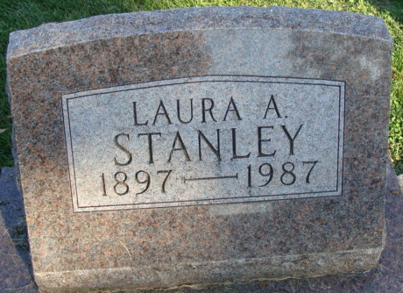
Photo by Alicia Kneuss

Laura A Stanley
in the Indiana, U.S., Death Certificates, 1899-2017
Name Laura A Stanley
Gender Female
Race White
Marital Status Never Married (Single)
Age 90
Birth Date 28 Jan 1897
Birth Place Indiana
Death Date 22 Apr 1987
Death Place Decatur, Adams, Indiana, USA
Death Registration Date 1987
Father Walter Leslie Stanley
Mother Elizabeth Ann Lammiman
Informant Mrs. Doris Grote; niece; Decatur, Indiana
Burial April 25, 1987; Decatur Cemetery; Decatur, Indiana

