Eula May (Mullins) Stanley
May 18, 1894 – November 9, 1983

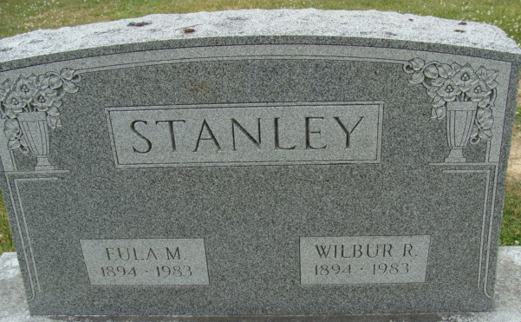
Photo by Alicia Kneuss

Eula May Stanley
in the Indiana, U.S., Death Certificates, 1899-2017
Name Eula May Stanley
[Eula May Mullins]
Gender Female
Race White
Marital Status Married
Age 89
Birth Date 18 May 1894
Birth Place Virginia
Death Date 9 Nov 1983
Death Place Bluffton, Wells, Indiana, USA
Death Registration Date 1983
Father Joe Mullins
Mother Martha Thornton
Spouse Wilbur Stanley
Informant Wilbur Stanley; husband; Monroe, Indiana
Burial November 11, 1983; Decatur Cemetery; Decatur, Indiana

