Elsie K. (Schafer) Stanley
October 7, 1893 – December 20, 1952

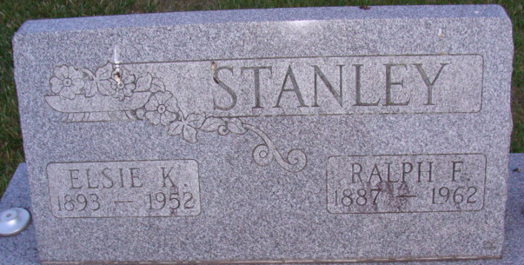
Photo by Alicia Kneuss

Elsie K Stanley
in the Indiana, U.S., Death Certificates, 1899-2017
Name Elsie K Stanley
[Elsie K Schafer]
Gender Female
Race White
Marital Status Married
Age 59
Birth Date 7 Oct 1893
Birth Place Ft. Wayne, Indiana
Death Date 20 Dec 1952
Death Place Decatur, Adams, Indiana, USA
Death Registration Date 1952
Father George Schafer
Mother Sophia Hockemeyer
Informant Mr. Ralph Stanley; Decatur, Indiana
Burial December 23, 1952; Maplewood Cemetery; Decatur, Indiana

