Edith May Stanley
July 14, 1919 – January 29, 1945

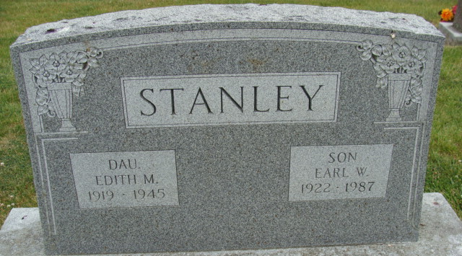
Photo by Deb Curry

INVALID DIES NEAR MONROE MONDAY P.M.

Edith May Stanley, 25, died Monday afternoon at the home of her parents, Mr. and Mrs. Wilbur Stanley, near Monroe, in Washington Township. She had been an invalid for many years.
She was born in Ferrun, Va., July 14, 1919, the daughter of Wilbur R. and Eula May Mullins-Stanley. The family moved to Adams County eight years ago.
Surviving, in addition to the parents, are a brother, Earl Stanley, at home, and a grandmother, Mrs. George Stanley of Roanoke, Va.

The Berne Witness; Adams County, Indiana
Wednesday, January 31, 1945

