Earl Willis Stanley
August 29, 1922 – February 16, 1987

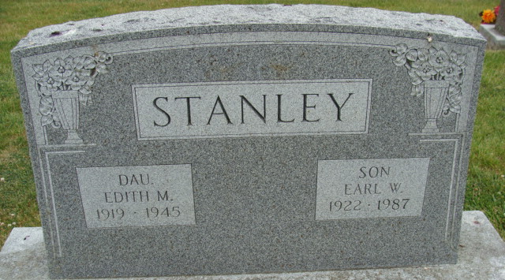
Photo by Deb Curry

Willis Earl Stanley
in the Indiana, U.S., Death Certificates, 1899-2017

Name Willis Earl Stanley
Gender Male
Race White
Marital Status Never Married (Single)
Age 64
Birth Date 29 Aug 1922
Birth Place Virginia
Death Date 16 Feb 1987
Death Place Bluffton, Wells, Indiana, USA
Death Registration Date 1987
Father Wilbur R Stanley
Mother Eula May Mullins
Informant Floyd A. Marshand; Decatur, Indiana
Burial February 19, 1987; Decatur Cemetery; Decatur, Indiana

