Jacob Stanger
March 6, 1876 – March 31, 1966

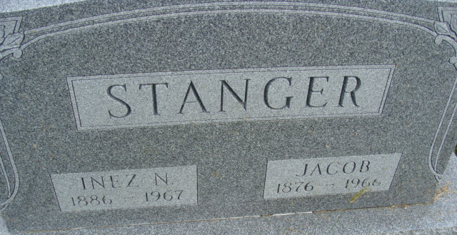
Photo by Deb Curry

Jacob Stanger
in the Indiana, U.S., Death Certificates, 1899-2017
Name Jacob Stanger
Gender Male
Race White
Marital Status Married
Age 90
Birth Date 6 Mar 1876
Birth Place Fort Wayne, Indiana
Death Date 31 Mar 1966
Death Place Fort Wayne, Allen, Indiana, USA
Death Registration Date 1966
Father Henry Stanger
Mother Sarah Engle
Informant Inez Stanger; wife; Fort Wayne, Indiana
Burial April 2, 1966; Maplewood Cemetery; Decatur, Indiana

