Inez N. (Aspy) Stanger
August 18, 1886 – November 12, 1967

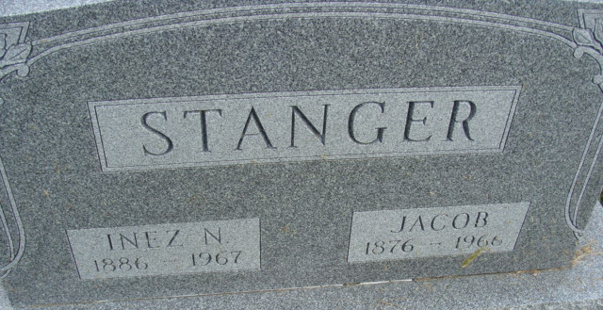
Photo by Deb Curry

Inez N Stanger
in the Indiana, U.S., Death Certificates, 1899-2017
Name Inez N Stanger
Gender Female
Race White
Marital Status Widowed
Age 81
Birth Date 18 Aug 1886
Birth Place Fort Wayne, Idiana
Death Date 12 Nov 1967
Death Place Fort Wayne, Allen, Indiana, USA
Death Registration Date 1967
Father Not Available
Mother Not Available
Informant Gerald Aspy; brother; Hoagland, Indiana
Burial November 15, 1967; Decatur Cemetery; Decatur, Indiana
**
Indiana, U.S., Marriages, 1810-2001
Name Inez N Aspy
Gender Female
Race White
Age 43
Event Type Marriage Registration (Marriage)
Birth Date 18 Aug 1886
Birth Place Chicago, Illinois
Marriage Date 31 Dec 1929
Marriage Place Indiana, United States
Father Marshall S Aspy
Mother Susan Hotsenpillar
Spouse Jacob Stanger
Page 43

