Ruth Lynn Stanford
November 5, 1961 – December 2, 1961

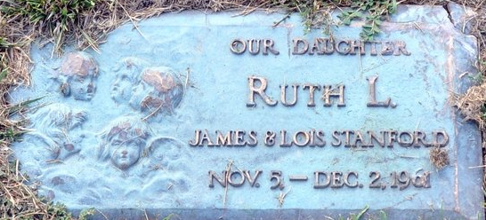
Photo by Deb Curry

Ruth Lynn Stanford
in the Indiana, U.S., Death Certificates, 1899-2017
Name Ruth Lynn Stanford
Gender Female
Race White
Age 0
Birth Date 5 Nov 1961
Birth Place Illinois
Death Date 2 Dec 1961; auto accident
Death Place Fort Wayne, Allen, Indiana, USA
Death Registration Date 1961
Father James D Stanford
Mother Lois B Suman
Informant Mrs. Ruth Suman; grandmother; Decatur, Indiana
Burial December 4, 1961; Decatur Cemetery; Decatur, Indiana

