William Luster Standiford
April 26, 1870 – October 30, 1951

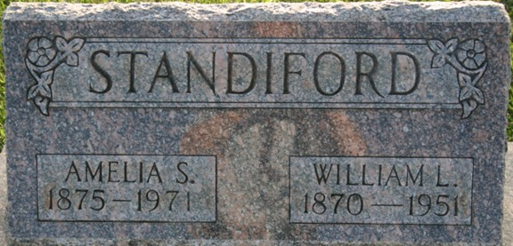
Photo by Margie Pearce

William L. Standiford, 81, died at 8:35 p.m. yesterday at his home, 4519 South Lafayette Street. He had been ill several months. Mr. Standiford formerly was a switchman with the Pennsylvania Railroad, having retired 15 years ago. He was a member of the Evangelical United Brethren Church.
The body was taken to the C.M. Sloan & Sons Funeral Home, where friends may call after 7 p.m. today.
Surviving are his wife, Amelia; a sister, Mrs. Fannie Jackson, Decatur, Frank, Wren, O., and Charles, Rockford, O.

Journal-Gazette, Allen County, Indiana
Wednesday, October 31, 1951
**
William Luster Standiford from tree Helm & Lammert
Birth 26 Apr 1870 Lima, Allen, Ohio, USA
Marriage 1893
Residence 1 Apr 1940 Fort Wayne, Allen, Indiana, USA
Death 30 Oct 1951 Allen, Indiana, USA
Father George W Standiford (1842-1915)
Mother Adaline Shockey (1843-1905)
Spouse Amelia S Roth (1875-1971)

